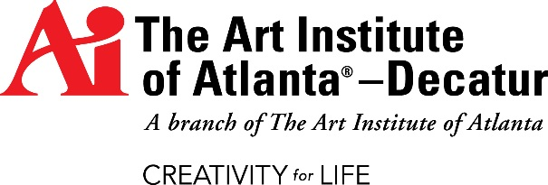
FACT SHEET

MEDIA CONTACT
Contact: Devra Pransky, Senior Director of Communications, Phone: (412) 995.7685 (office); (412) 657.8413 (mobile); or dpransky@edmc.edu

CAMPUS DIRECTOR
Sharon Clay

ABOUT THE ART INSTITUTE OF ATLANTA–DECATUR
- The Art Institute of Atlanta–Decatur, a branch of The Art Institute of Atlanta, is one of The Art Institutes, a system of more than 50 educational institutions located across North America.
- The Art Institutes provide programs in design, media arts, fashion and culinary.
- The Art Institute of Atlanta–Decatur was founded in 2007 and occupies more than 20,000 square feet of classrooms, computer labs, art studios, a photography studio and digital editing suite, an animation lab, a fashion lab, a library and office space.
- The Gallery is a community resource open to the public, hosting more than a half dozen exhibitions of art and design each year by students, faculty, alumni and guest artists.
- College-sponsored housing is available.
- The campus offers a library with more than 6,000 items, including books, DVDs, and CD-ROMs, as well as access to multiple databases, including Proquest, Vogue Archives, Digital Tutors, Women’s Wear Daily, Gnomon, Stash and Ebsco.

PROGRAMS OFFERED

Associate of Arts | Graphic & Web Design
Bachelor of Arts | Advertising
Bachelor of Arts | Fashion Marketing & Management
Bachelor of Fine Arts | Digital Photography
 | Fashion Design
 | Game Art & Design
 | Graphic & Web Design
 | Media Arts & Animation
Diploma | Advertising Design
 | Digital Image Management
 | Fashion Retailing
 | Web Design & Interactive Communications

COMMUNITY SERVICE PARTNERS
The Art Institute of Atlanta–Decatur works with numerous non-profit organizations each year, providing various services at no cost to our partners, some of whom are listed below.
- Literacy Volunteers
- Decatur Arts Alliance
- Decatur Arts Festival
- Easter Seals
- Jewish Family & Career Services
- YMCA
- Wonder Root

INSTITUTIONAL ACCREDITATION
The Art Institute of Atlanta–Decatur is a branch campus of The Art Institute of Atlanta. The Art Institute of Atlanta is accredited by the Southern Association of Colleges and Schools Commission on Colleges to award associate and baccalaureate degrees. Contact the Commission on Colleges at 1866 Southern Lane, Decatur, Georgia 30033-4097 or call 404.679.4500 for questions about the accreditation of The Art Institute of Atlanta.

STATE LICENSING
The Art Institute of Atlanta–Decatur meets the criteria for an exemption from the Georgia Nonpublic Postsecondary Education Commission’s (NPEC) regulations as outlined in O.C.G.A.§20-3-250.3(a)(15).

The Art Institute of Atlanta–Decatur is licensed by the Alabama Department of Postsecondary Education, 401 Adams Avenue, Montgomery, Alabama, 36104-4340 and is approved for recruiting purposes only by the Alabama Commission on Higher Education, 100 North Union Street, Montgomery, Alabama 36104-3758.

LOCATION
The Art Institute of Atlanta–Decatur
A branch of The Art Institute of Atlanta
One West Court Square
Suite 110
Decatur, GA 30030
404.942.1800 or 1.866.856.6203
new.artinstitutes.edu/atlanta-decatur

See aiprograms.info for program duration, tuition, fees, and other costs, median debt, federal salary data, alumni
success, and other important info.

Programs, credential levels, technology, and scheduling options are subject to change. The Art Institute of Atlanta-Decatur, a branch of The Art Institute of Atlanta, One West Court Square, Suite 110, Decatur, GA 30030. ©2015 The Art Institutes International LLC. Our email address is csprogramadmin@edmc.edu.

