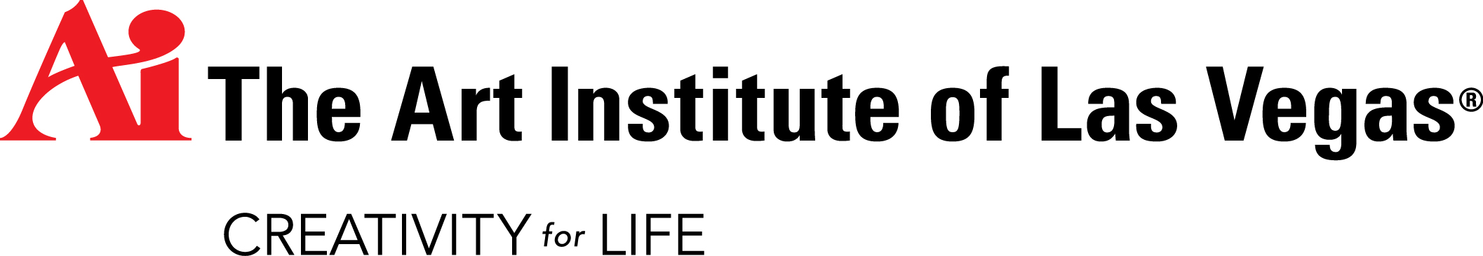
FACT SHEET
MEDIA CONTACT
Contact: Devra Pransky, Senior Director of Communications, Phone: (412) 995.7685 (office); (412) 657.8413 (mobile); or dpransky@edmc.edu

PRESIDENT
Mark Garland

ABOUT THE ART INSTITUTE OF LAS VEGAS
- The Art Institute of Las Vegas is one of The Art Institutes, a system of more than 50 educational institutions located across North America.
- The Art Institutes provide programs in design, media arts, fashion and culinary.
- The International Culinary School at The Art Institute of Las Vegas was formerly known as The Culinary Institute of Las Vegas, a division of The Art Institute of Las Vegas.
- The Art Institute of Las Vegas was founded in 1983 and known as the Interior Design Institute and later the Design Institute. The school became part of The Art Institutes system in April 2001. In 2006, The Art Institute of Las Vegas opened a branch campus, The Art Institute of Indianapolis.
- The school consists of approximately 45,000 square feet of classroom, computer lab, library, professional skills kitchens, a dining lab and office space.

PROGRAM OFFERINGS

Associate of Science | Baking & Pastry
 | Culinary Arts
 | Digital Photography
 | Drafting Technology & Design
Bachelor of Arts | Fashion Design
 | Interior Design
Bachelor of Science | Advertising
 | Audio Production
 | Culinary Management
 | Digital Filmmaking & Video Production
 | Digital Photography
 | Fashion & Retail Management
 | Game Art & Design
 | Graphic Design
 | Media Arts & Animation
 | Visual Effects & Motion Graphics
 | Web Design & Interactive Media
Certificate of Professional Development | Wine Education
Diploma | Baking & Pastry
 | Culinary Arts
 | Digital Image Management
 | Fashion Retailing
 | Web Design & Development
 | Web Design & Interactive Communications

INSTITUTIONAL ACCREDITATION
The Art Institute of Las Vegas is accredited by the Accrediting Council for Independent Colleges and Schools to award diplomas, associate’s degrees, and bachelor’s degrees. The Accrediting Council for Independent Colleges and Schools is listed as a nationally recognized accrediting agency by the United States Department of Education and is recognized by the Council for Higher Education Accreditation. ACICS can be contacted at 750 First Street NE, Suite 980, Washington, D.C. 20002. Telephone: 1.202.336.6780.

PROGRAMMATIC ACCREDITATION
The Bachelor of Arts in Interior Design degree program is accredited by the National Kitchen & Bath Association (NKBA). NKBA can be contacted at 687 Willow Grove Street, Hackettstown, NJ 07840,1-800-THE-NKBA, www.nkba.org.

The Interior Design program leading to the Bachelor of Arts degree is accredited by the Council for Interior Design Accreditation, www.accredit-id.org, 206 Grandville Ave., Ste. 350, Grand Rapids, MI 49503.

The Associate of Science in Baking & Pastry, Associate of Science in Culinary Arts and Bachelor of Arts in Culinary Management programs are accredited by The Accrediting Commission of the American Culinary Federation Education Foundation.

STATE LICENSING
The Art Institute of Las Vegas is licensed to operate by the Commission on Postsecondary Education; 3663 East Sunset Road, Suite 202, Las Vegas NV 89120; 702.486.7330.

CONTINUING EDUCATION
The Art Institute of Las Vegas has a Center for Professional Development. Due to the regulatory agencies’ review process for these types of programs, Regulatory Affairs & Compliance will not be monitoring them. As reported by the school, the center offers the following: Wine Education (WW).

LOCATION
The Art Institute of Las Vegas
2350 Corporate Circle
Henderson, NV 89074 -7737
Phone: 1.800.833.2678 or 702.369.9944
new.artinstitutes.edu/las-vegas

See aiprograms.info for program duration, tuition, fees, and other costs, median debt, federal salary data, alumni success, and other important info.

Programs, credential levels, technology, and scheduling options are subject to change. The Art Institute of Las Vegas, a branch of The Art Institute of Phoenix, 2350 Corporate Circle, Henderson, NV 89074-7737. ©2015 The Art Institutes. Our email address is csprogramadmin@edmc.edu.
.

